1. Manage Audit Dashboard   
   Unplanned Audit🡪 Click

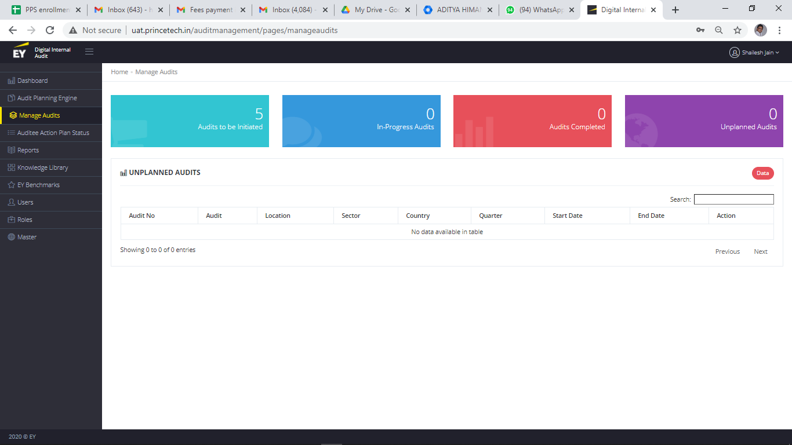

Add a button to add Unplanned Audit

On Click open Following Form

Audit planning Engine🡪Menu 🡪 Audit Plan 🡪 Schedule

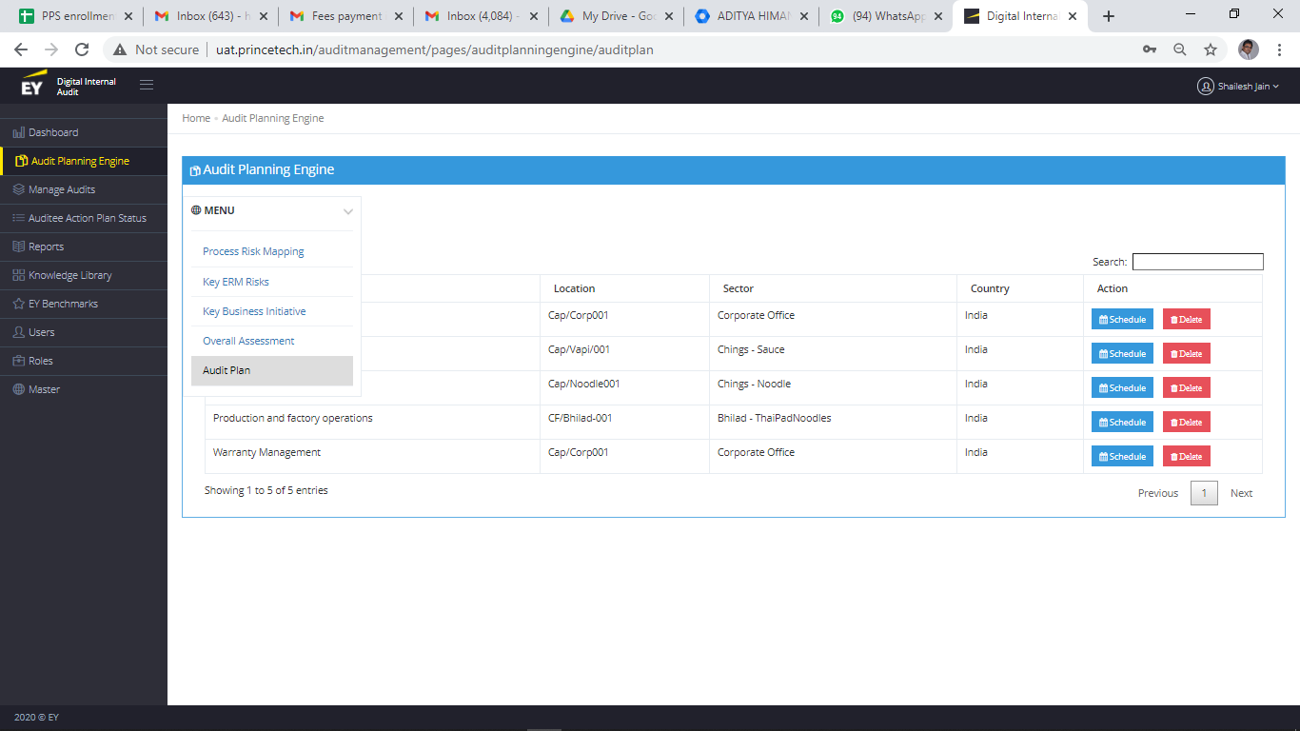

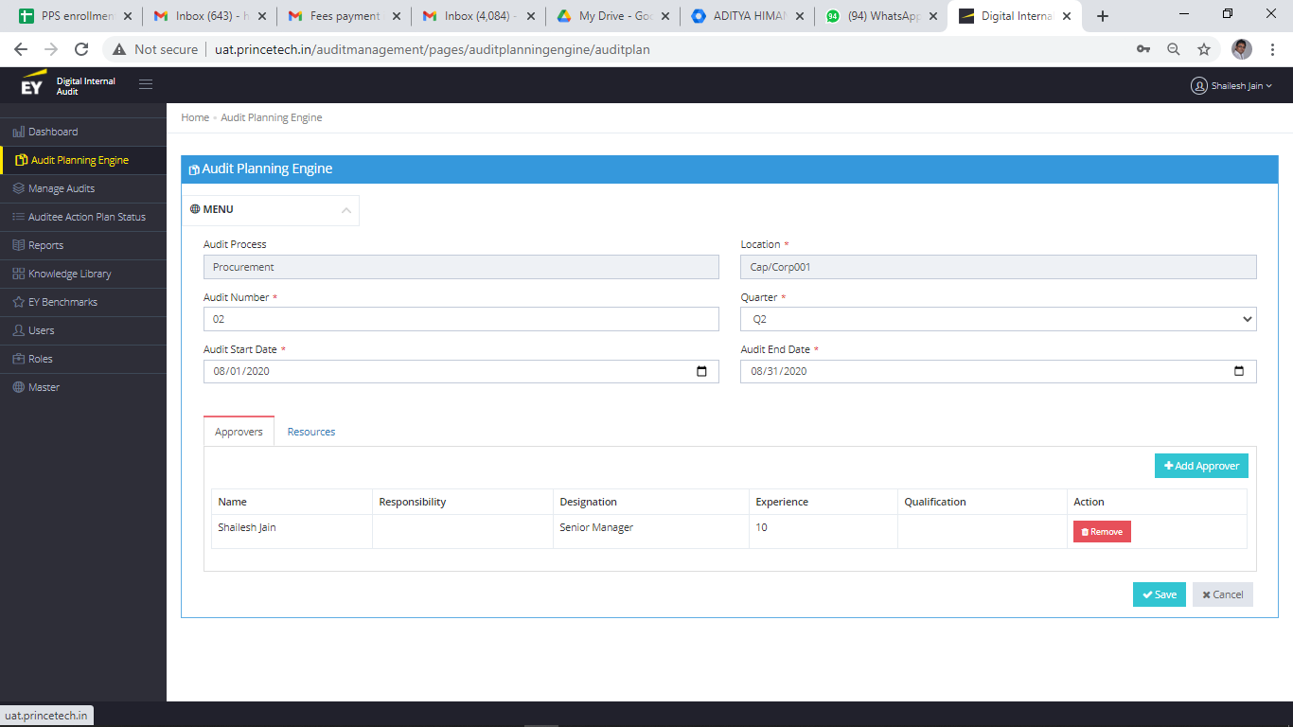

In this form add File upload option

2)Manage Audit🡪Click on Action 🡪 Planning 🡪Data Tracker

In add and Edit Give a option to upload the file

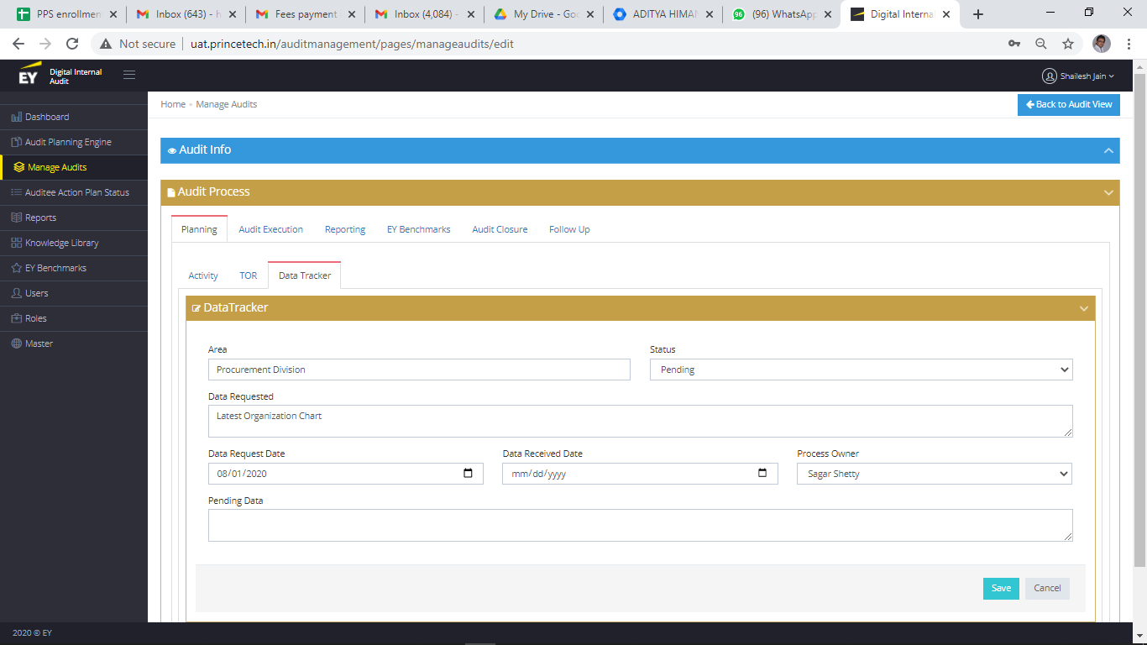

1. Draft and Final Report Export To Excel
2. TOR File upload option
3. Change following Fields in Draft Report

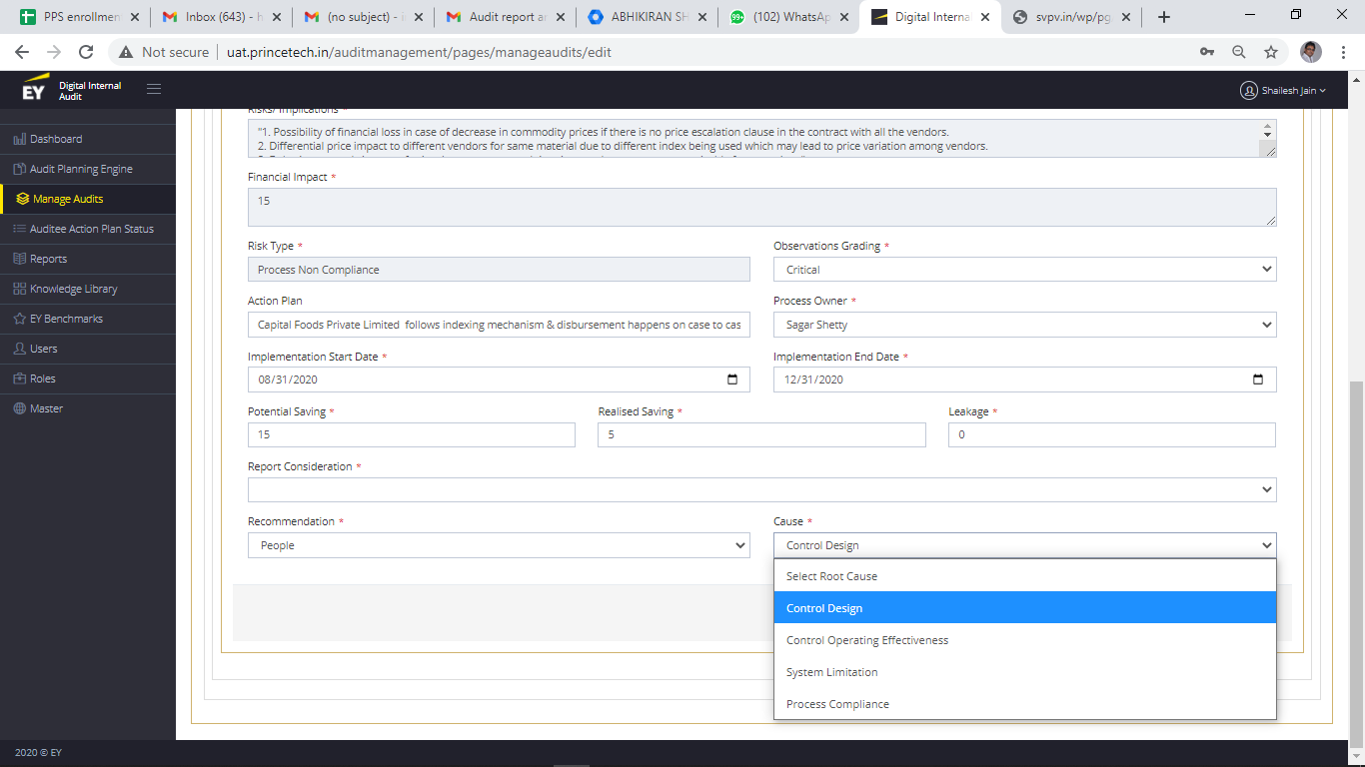

* Multiple Selection i.e. put Check box for Cause and Recommendation
* Add field Background and detailed observation
* Add business impact drop down with following Values

Reporting Impact

Operational Impact

Statutory non-compliance

Reputational loss